Vizard practicum week 3 B

Semester:
Course: VR3d
Version:1.0
Author: Michael Schifferling

Introduction.
This week the focus will be on special effects to really bring the scene to life. We will take a look at billboarding and particles.

Billboarding.
Billboarding in Vizard is a fairly straightforward.
Create a scene and add 3 textured quads with billboard textures. Try to find a few interesting textures, for example a tree, a planet or a flame.
There are 3 billboarding modes supported in Vizard:
- viz.BILLBOARD_VIEW
- viz.BILLBOARD_YAXIS
- viz.BILLBOARD_VIEW_POS
Show all of these modes in the scene. Explain when to use these modes. What effect do you want to achieve?

Particles
Vizard has built in support for particles. How to use them is explained in the Vizard Reference (reference->3d models.>particle systems)
-Download the zip file “Vizard practicum week 3 a” from sharepoint:
Extract particles.zip and open the Vizard project. When you run the project You should see something like this:
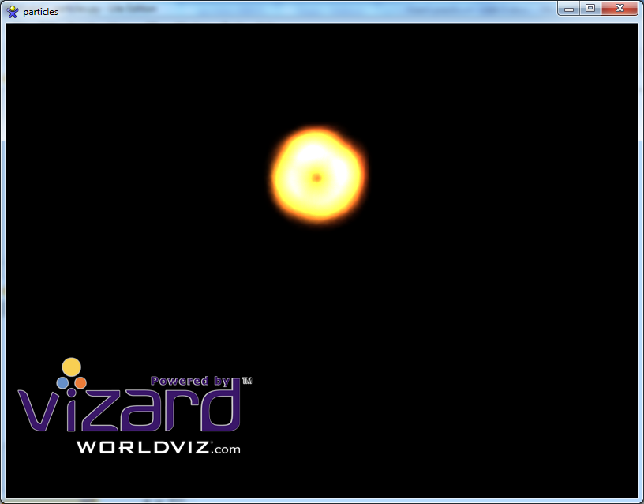
-Open fire .osg
Look for the particleTemplate element and the RadialShooter element and make adjustments to the particle and emitter settings. Which settings have you changed and what do they do?

(Optional) Homemade particle engine
As you’ve seen in the previous step, Vizard does support particle systems. However editing and changing the particle settings is not really straightforward without OSGEdit.We are now going to create our own simple particle emitter. Extract MyParticleEmitter.zip and open the Vizard project. When you run the project you see a simple emitter, emitting blue particles.
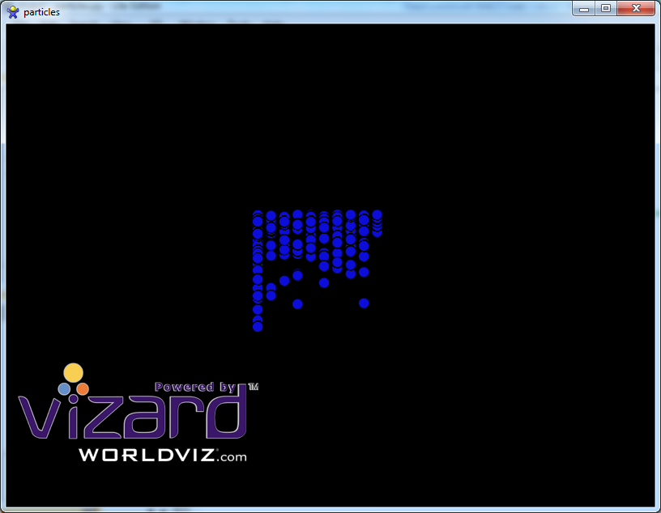
Now it’s up to you to make the particle emitter project better. Add the following to the emitter project:
- Random birth parameters. Particles should have random properties, such as size, color, maxlife, speed, direction etc.
- The emitter now constantly has 200 particles. Change the emitter to have it emit a number of particles per second. This is often called the birthrate or spawning rate.
- Add an emitter position, so that you can move the emitter. The particle spawn position should be based on the particle emitter position.
- Changing parameters over time. Update particle properties over time, such as color and size. Let a particle start out red, and end with blue for example. Or start with size 0.1 and end with 10 (or vice versa).
- Multiple particle textures. Create a few more alpha mapped textures. Maybe a small dot or a cloudy speck. Maybe even lines. Maybe you can make a the small dot particle move very fast to mimic sparks, and make the cloudy particle start out small and dark, and end up big and bright, to emulate smoke.
- Add a gravity component to the particles, so that over time they can fall down. To do this, decrement the velocity aspect of the particle over time, so that only the gravity component has effect on the particle position.
- Add a particle attractor that pulls particles to it. This can be achieved by constantly setting the particle direction to face the particle attractor position.
Many of the items mentioned above can be easily implemented by subclassing the particle object. For example by creating a SmokeParticle that inherits from Particle. The emitter can then choose which particle to create.
With the above items implemented, create a scene to showcase the emitter (or multiple emitters).
Be creative.
Try to add as many interesting effect as possible. Add a fire emitter, or an explosion emitter. Or a bouncing marbles emitter where particle bounce of a surface. Maybe you can create a cloud generator or even a swarm of flies (textured fly particle).

Unity practicum week 3b

Instructional Links
There are many links that might help you getting started, but this one is very elaborate and explains all settings:
- https://unity3d.com/learn/tutorials/topics/graphics/particle-system

Assignment
- Make an object that behaves as a billboard by using a script. Make 2 versions:
- one that always faces the camera, also when the camera movers upward, and
- one that always stays vertical, but rotates around the vertical (y-) axis towards the camera.
- Create at least 2 different particle systems to model some realistic effects.
Some suggestions (but feel free to differ):
- Fountain
- Waterfall
- Water coming out of a hose
- Fire with smoke
- Fireworks
- Explosion
- Smoke from a rocket or jetplane engine
- Rain that makes bubbles on the ground
- Etcetera
In the above particle systems, use at least 4 of the features between “Shape” and “Renderer”:
